**Exercise 1: Configuring a Basic Spring Application**

**Scenario:**

Your company is developing a web application for managing a library. You need to use the Spring Framework to handle the backend operations.

**SOLUTION:**

**Project Setup:**

* Project Name: LibraryManagement
* Type: Maven Project
* Framework: Spring Core (NOT Spring Boot)
* Purpose: Manage library backend with service and repository layers using Spring XML configuration

**1. Create Maven Project**

**GroupId: com.library  
ArtifactId: LibraryManagement  
Packaging: jar**

**pom.xml with Spring Core Dependencies**

**xml**

<project xmlns="http://maven.apache.org/POM/4.0.0"

xmlns:xsi="http://www.w3.org/2001/XMLSchema-instance"

xsi:schemaLocation="http://maven.apache.org/POM/4.0.0

http://maven.apache.org/xsd/maven-4.0.0.xsd">

<modelVersion>4.0.0</modelVersion>

<groupId>com.library</groupId>

<artifactId>LibraryManagement</artifactId>

<version>1.0</version>

**<dependencies>**

**<!-- Spring Core -->**

<dependency>

<groupId>org.springframework</groupId>

<artifactId>spring-context</artifactId>

<version>5.3.34</version>

</dependency>

</dependencies>

</project>

**2. Create XML Configuration File**

<?xml version="1.0" encoding="UTF-8"?>

<beans xmlns="http://www.springframework.org/schema/beans"

xmlns:xsi="http://www.w3.org/2001/XMLSchema-instance"

xsi:schemaLocation="

http://www.springframework.org/schema/beans

http://www.springframework.org/schema/beans/spring-beans.xsd">

<bean id="bookRepository" class="com.library.repository.BookRepository"/>

<bean id="bookService" class="com.library.service.BookService">

<property name="bookRepository" ref="bookRepository"/>

</bean>

</beans>

**3. Create Classes**

package com.library.repository;

public class BookRepository {

public String getBookTitle() {

return "Spring in Action";

}

}

package com.library.service;

import com.library.repository.BookRepository;

public class BookService {

private BookRepository bookRepository;

public void setBookRepository(BookRepository bookRepository) {

this.bookRepository = bookRepository;

}

public void displayBook() {

System.out.println("Book Title: " + bookRepository.getBookTitle());

}

**}**

**4. Main Class to Run the Application**

**com.library.MainApp.java**

package com.library;

import com.library.service.BookService;

import org.springframework.context.ApplicationContext;

import org.springframework.context.support.ClassPathXmlApplicationContext;

public class MainApp {

public static void main(String[] args) {

ApplicationContext context = new ClassPathXmlApplicationContext("applicationContext.xml");

BookService bookService = context.getBean("bookService", BookService.class);

bookService.displayBook();

}

**}**

**OUTPUT**

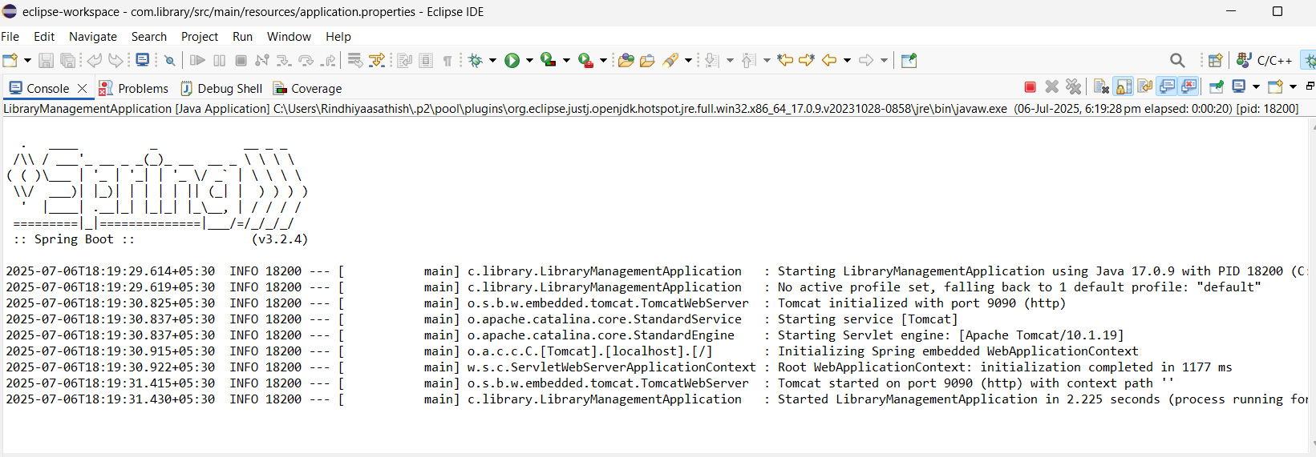

**Exercise 2: Implementing Dependency Injection**

**Scenario:** In the library management application, you need to manage the dependencies between the BookService and BookRepository classes using Spring's IoC and DI.

**Update the applicationContext.xml file:**

<?xml version="1.0" encoding="UTF-8"?>

<beans xmlns="http://www.springframework.org/schema/beans"

xmlns:xsi="http://www.w3.org/2001/XMLSchema-instance"

xsi:schemaLocation="

http://www.springframework.org/schema/beans

http://www.springframework.org/schema/beans/spring-beans.xsd">

<bean id="bookRepository" class="com.library.repository.BookRepository"/>

<bean id="bookService" class="com.library.service.BookService">

<property name="bookRepository" ref="bookRepository"/>

</bean>

</beans>

**Update the BookService.java**

package com.library.service;  
import com.library.repository.BookRepository;  
  
public class BookService {  
  
 private BookRepository bookRepository;  
  
 // Setter for DI  
 public void setBookRepository(BookRepository bookRepository) {  
 this.bookRepository = bookRepository;  
 }  
  
 public void serve() {  
 System.*out*.println("BookService is working.");  
 // Use BookRepository to confirm DI works  
 bookRepository.display();  
 }  
}

**output**

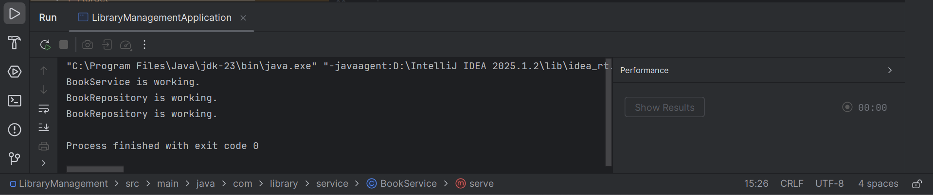

**Exercise 4: Creating and Configuring a Maven Project**

**Scenario:** You need to set up a new Maven project for the library management application and add Spring dependencies.

**Code**

<dependency>

<groupId>org.springframework</groupId>

<artifactId>spring-context</artifactId>

<version>5.3.30</version> <!-- Or any stable version -->

</dependency>

<dependency>

<groupId>org.springframework</groupId>

<artifactId>spring-aop</artifactId>

<version>5.3.30</version>

</dependency>

<dependency>

<groupId>org.springframework</groupId>

<artifactId>spring-webmvc</artifactId>

<version>5.3.30</version>

</dependency>

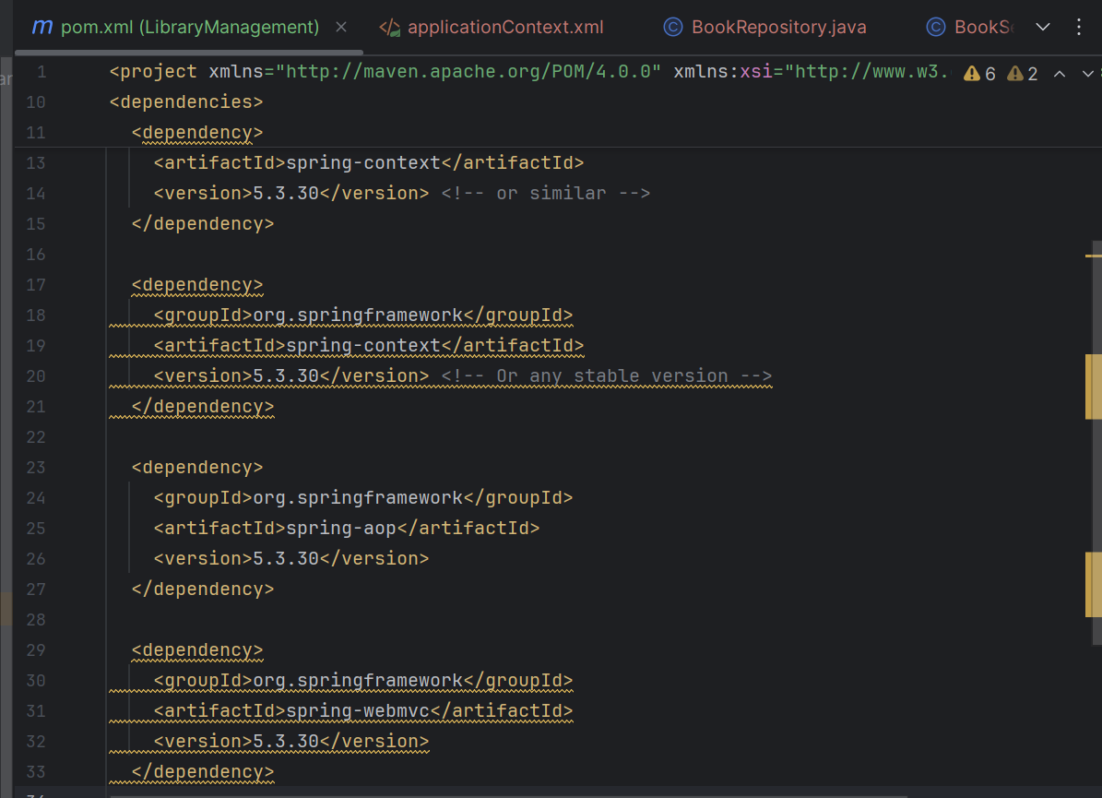

**Add the Maven Compiler Plugin:**

<build>

<plugins>

<plugin>

<groupId>org.apache.maven.plugins</groupId>

<artifactId>maven-compiler-plugin</artifactId>

<version>3.10.1</version>

<configuration>

<source>1.8</source> <!-- Or 17 if you're using JDK 17 -->

<target>1.8</target>

</configuration>

</plugin>

</plugins>

</build>

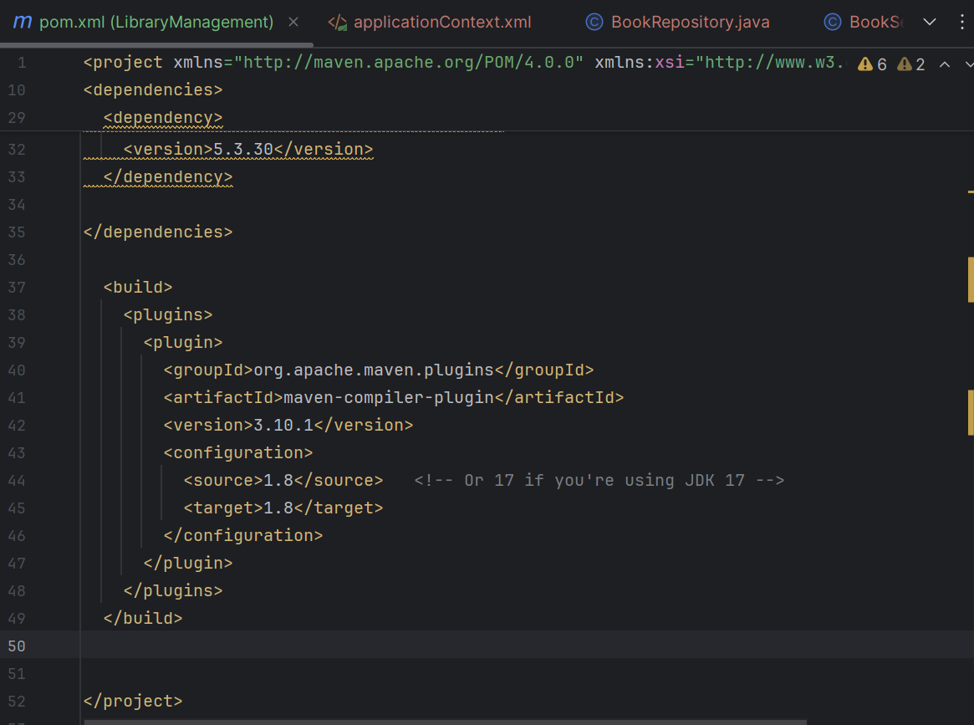

We can see that the plugins are added successfully

